SCHOOL

Trial WACE Examination, 2010

Question/Answer Booklet

MATHEMATICS
SOLUTIONS

3C/3D

Section Two:

Calculator-assumed

Student Number: In figures

In words

Your name

Time allowed for this section
Reading time before commencing work: 10 minutes
Working time for paper: 100 minutes

Material required/recommended for this section

To be provided by the supervisor
This Question/Answer booklet
Formula sheet (retained from Section One)

To be provided by the candidate
Standard items: pens, pencils, pencil sharpener, eraser, correction fluid, ruler, highlighters

Special items: drawing instruments, templates, notes on two unfolded sheets of A4 paper, and up to three calculators satisfying the conditions set by the Curriculum Council for this course.

Important note to candidates

No other items may be used in this section of the examination. It is your responsibility to ensure that you do not have any unauthorised notes or other items of a non-personal nature in the examination room. If you have any unauthorised material with you, hand it to the supervisor before reading any further.

Structure of this paper

Section | Number of questions available | Number of questions to be answered | Working time (minutes) | Marks available
Section One:  Calculator-free | 8 | 8 | 50 | 40
Section Two:  Calculator-assumed | 12 | 12 | 100 | 80
 |  |  |  | 120

Instructions to candidates

- The rules for the conduct of Western Australian external examinations are detailed in the Year 12 Information Handbook 2010. Sitting this examination implies that you agree to abide by these rules.

- Write your answers in the spaces provided in this Question/Answer Booklet. Spare pages are included at the end of this booklet. They can be used for planning your responses and/or as additional space if required to continue an answer.
- Planning: If you use the spare pages for planning, indicate this clearly at the top of the page.
- Continuing an answer: If you need to use the space to continue an answer, indicate in the original answer space where the answer is continued, i.e. give the page number. Fill in the number of the question(s) that you are continuing to answer at the top of the page.

- Show all your working clearly. Your working should be in sufficient detail to allow your answers to be checked readily and for marks to be awarded for reasoning. Incorrect answers given without supporting reasoning cannot be allocated any marks. For any question or part question worth more than two marks, valid working or justification is required to receive full marks. If you repeat an answer to any question, ensure that you cancel the answer you do not wish to have marked.

- It is recommended that you do not use pencil except in diagrams.

Section Two: Calculator-assumed (80 Marks)
This section has twelve (12) questions. Answer all questions. Write your answers in the space provided.

Working time for this section is 100 minutes.

Question 9 (4 marks)
The percentage of trees, P, in a plantation affected by a disease was changing with time, t in months, according to the relationship 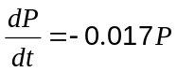.

(a) Was the health of the plantation getting better or worse? Briefly justify your answer by referring to the above relationship. (1 mark)
Better, as the rate of change of diseased trees with time is negative (-0.017) and hence decreasing.

(b) If 7.2% of the trees in the plantation were affected today, what percentage is expected to be affected by the disease in one and a half years time? (3 marks)

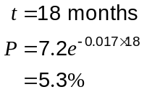

Question 10 (5 marks)
(a) A and B are two independent events such that 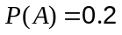 and 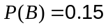.

Evaluate

(i) 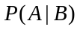 (1 mark)
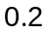

(ii) 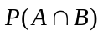 (1 mark)
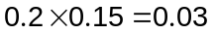

(iii) 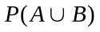 (1 mark)
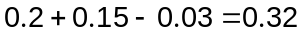

(b) The probability that a door to door salesman convinces a customer to buy is 0.4.

Assuming that sales are independent, find the probability that the salesman makes at least one sale before reaching the fourth house. (2 marks)
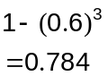

Question 11 (6 marks)
A body moves in a straight line so that its displacement, 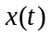metres, from a fixed point after seconds is given by 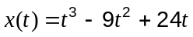, for 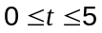.

(a) When is the body stationary? (2 marks)

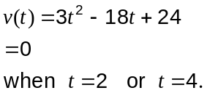

(b) When is the body moving fastest? (2 marks)

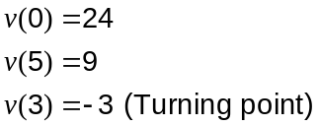

Hence fastest when 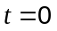

(c) Calculate the distance travelled by the body in the first four seconds. (2 marks)
Either
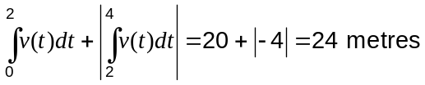
Or
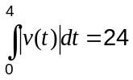

Question 12 (10 marks)
Every weekday the chef at a restaurant sends out an apprentice to the local market to spend as little as possible and at the same time come back with at least 16kg of onions, at least 17kg of carrots and at least 21kg of potatoes.

One stall at the market sells 'Best Buy' packs consisting of 2kg of onions, 1kg of carrots and 1kg of potatoes for $3.50 each. Another stall sells 'Chefs Choice' packs consisting of 1kg of onions, 2kg of carrots and 3kg of potatoes for $6.50 each.

The apprentice buys 'Best Buy' packs and 'Chefs Choice packs.

(a) Write down three inequalities to represent the above constraints, apart from 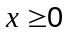 and 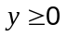. (2 marks)

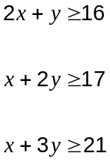

(b) Complete the constraints on the graph below and indicate the feasible region. (3 marks)
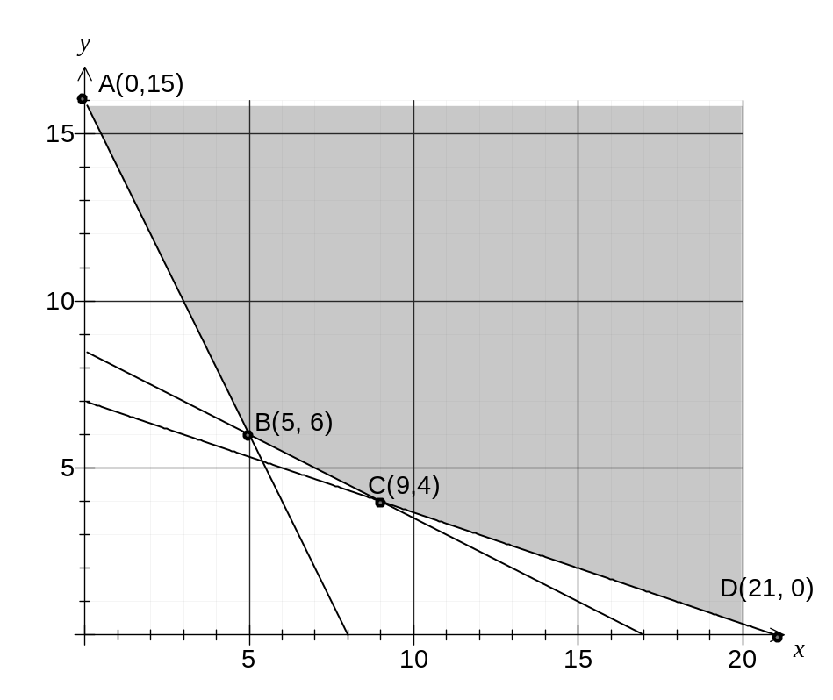

(c) How many of each pack should the apprentice buy to minimise the purchase cost and what is the minimum cost? (3 marks)
Point | Cost = 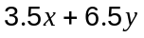
A(0, 16) | 104
B(5, 6) | 56.5
C(9, 4) | 57.5
D(21, 0) | 73.5

Hence buy 5 Best Buys and 6 Chefs Choice for minimum cost of $56.50.

(d) By how much can the price of a 'Best Buy' pack rise without changing the optimum number of packs found in your answer to (c)? (2 marks)
Let objective function be 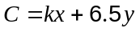

Then buy fewer Best Buys, so

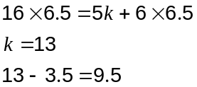

Price can increase by $9.50 before optimum solution will change.

Question 13 (5 marks)
A sub-committee of four, consisting of a chairperson, a secretary and two ordinary members is to be chosen from a committee of 20 people.

(a) Find the number of possible choices for

(i) the posts of chairperson and secretary, (1 mark)

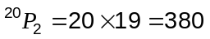

(ii) the two ordinary members, (1 mark)
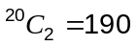

(iii) the chairperson, secretary and two ordinary members. (1 mark)
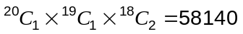

(b) If all possible sub-committees are equally likely to be chosen, what is the probability that the chairman of the main committee is not selected in the sub-committee? (2 marks)
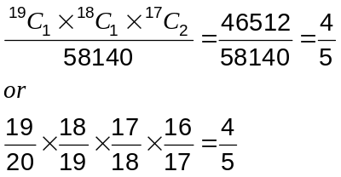

Question 14 (11 marks)
A manufacturer of chocolate produces 3 times as many soft centred chocolates as hard centred ones. The chocolates are randomly packed in boxes of 20.

(a) Find the probability that in a box there are

(i) an equal number of soft centred and hard centred chocolates (3 marks)
Let the rv 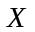 be the number of hard centred chocolates per box of 20.

Then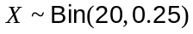

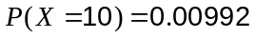

(ii) fewer than 5 hard centred chocolates. (1 mark)
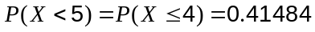

(b) Determine the mean and standard deviation of the number of hard centred chocolates in a box of 20. (2 marks)
Mean: 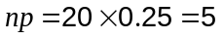

SD:

(c) A random sample of 5 boxes is taken from the production line. Find the probability that exactly 3 of them contain fewer than 5 hard centred chocolates. (2 marks)
Let the rv be the number of boxes out of 5 with fewer than 5 hard centres.

Then 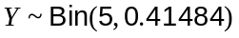

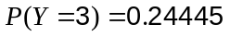

(d) A random sample of 30 boxes is taken from the production line. Find the probability that the mean number of hard centred chocolates per box in the sample exceeds 5.5.
(3 marks)
For samples of size 30 or more, CLT says distribution of sample means 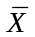 will be approximately normally distributed as follows:
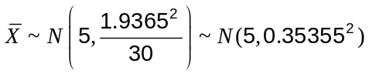
Hence 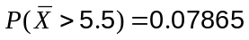
Question 15 (6 marks)
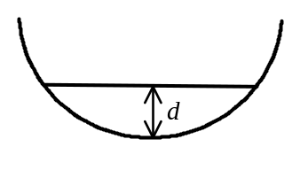When fluid rests in the bottom of a hemisphere of radius r, the volume of fluid V, can be calculated using the formula 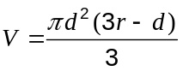, where is the depth of the fluid.

If water is poured into a hemisphere of radius 45cm at a constant rate of 2 litres per minute, how fast is the depth of water increasing at the instant that the hemisphere contains 70L of water?
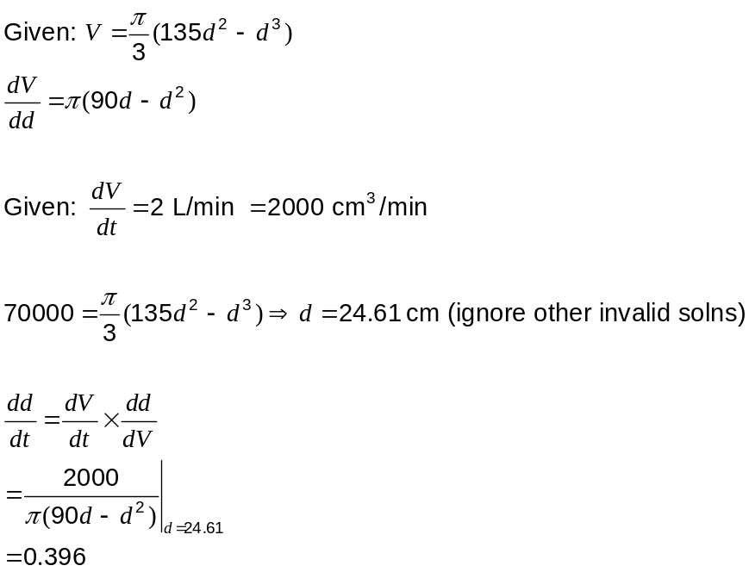

Hence depth is increasing at 0.396 cm per minute.

Question 16 (7 marks)
A factory uses three machines to produce one type of plastic bottle. Of the total production, machine A produces 35%, machine B produces 25% and machine C the rest. Due to the age of the machines, they all produce some defective bottles. Of their production, machines A and B produce 3% and 6% defective bottles respectively.

(a) Find the probability that a randomly selected bottle is produced by machine A and is defective. (1 mark)
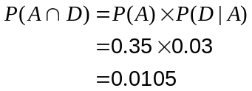

(b) If the probability of a randomly selected bottle being defective is 0.0455, what percentage of the production of machine C is defective? (4 marks)

Machine C has 100% - 35% - 25% = 40% of production.

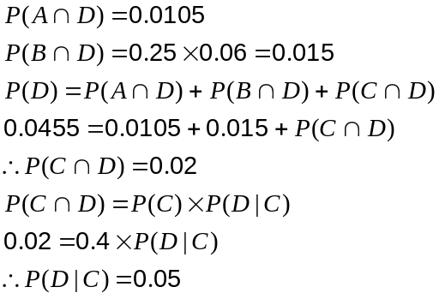

5% of output from C is defective.

(Tree diagram or 2-way table are alternative methods here)

(c) Given that a randomly selected bottle is not defective, find the probability that it was produced by either machine A or machine B. (2 marks)

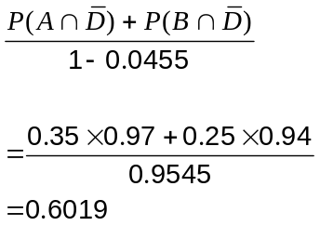

Question 17 (7 marks)
In the diagram below the chords AB and CD intersect at the point E.

The area of 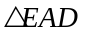 is 15cm².
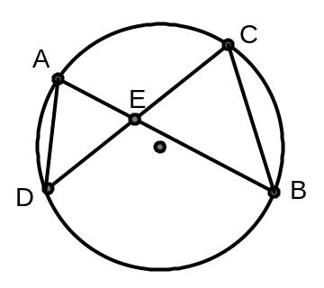

(a) Explain why 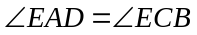 (1 mark)
Both angles stand on the arc BD.

(b) Prove that is similar to 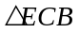. (3 marks)
 | Stand on arc BD
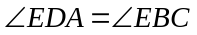 | Stand on arc AC
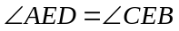 | Vertically opposite
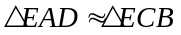 | AAA

(c) Use your result from (b) to show that 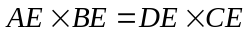. (1 mark)
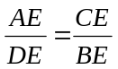 | Ratio of sides
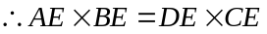

(d) Find the area of if 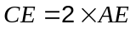. (2 marks)
If then 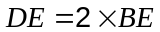.
Hence area of
Area 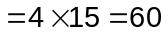cm².

Question 18 (7 marks)
Climbing rope produced by a manufacturer is known to be such that over a long production run, ten-metre lengths have breaking strengths that are normally distributed with a mean of 180.2kg and standard deviation of 9.5kg.

(a) Find the probability that a randomly chosen ten-metre length will have a breaking strength of less than 160kg. (1 mark)
0.0167

(b) At the start of a production run, a quality control officer at the factory randomly samples 20 ten-metre lengths and after testing, determines that the mean breaking strength of the sample is 176.9kg. Construct a 90% confidence interval for the population mean based on this sample. (3 marks)
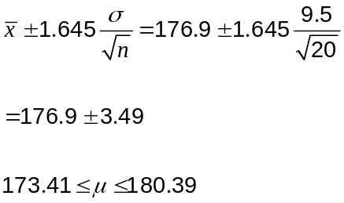

(c) If the quality control officer repeated the same sampling process in (b) every day for 30 consecutive days, how many of the intervals constructed would be expected to include the known mean breaking strength of 180.2kg? You may assume there were no problems with the manufacturing process. (1 mark)
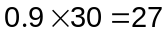days.

(d) How large a sample should the quality control officer take, if the probability that the estimated mean breaking strength is in error by more than 2.5kg is to be at most 5%?
(2 marks)
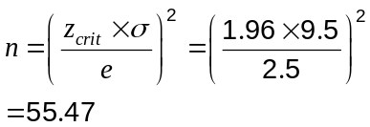

Hence sample 56 lengths of rope.

Question 19 (7 marks)
The graph below, not to scale, shows the functions 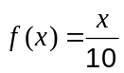, 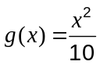 and the line 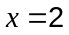.
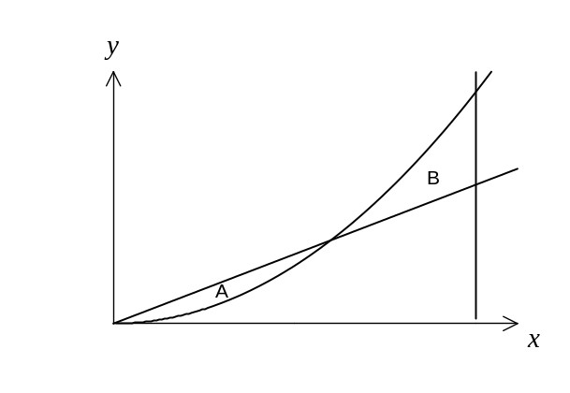
Region A is the area trapped by 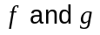.
Region B is the area trapped by 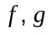 and the line .

(a) Find the areas of regions A and B. (3 marks)
f and g intersect when 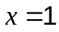.
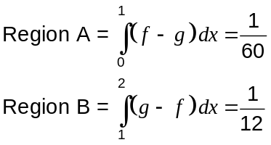

(b)  is modified to become the line 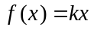, so that the area of region A is exactly the same as the area of region B. Determine the value of . (4 marks)
f and g intersect when 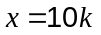.
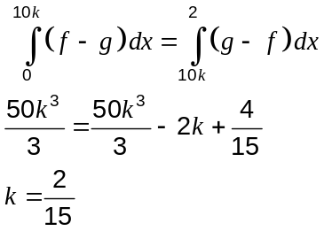
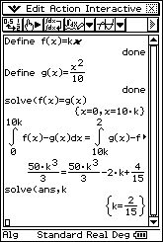

Question 20 (5 marks)
A random variable X is normally distributed such that the mean is twice the variance and the probability that X is greater than 21.5 is 0.231. Find the mean and standard deviation of X.
Let x = standard deviation and y = mean.
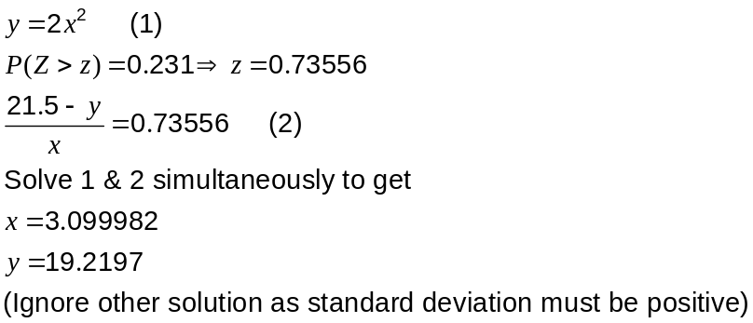
Hence mean is 19.22 and standard deviation is 3.10 (2dp).

Additional working space

Question number(s):

